NAME: SIVARANJANII.M DATE:18.08.25 ROLL NO.:241901109

EXERCISE 2
TCP CLIENT – SERVER USING SOCKET PROGRAMMING IN PYTHON

AIM:
To implement TCP client–server communication using socket programming in Python.

ALGORITHM:
SERVER:
- Create a socket using socket.socket().
- Bind the socket to an IP and port using bind ().
- Listen for client connections using listen ().
- Accept client connection using accept ().
- Receive data using recv ().
- Send response using send ().
- Close connection.

CLIENT:
- Create a socket using socket.socket().
- Connect to the server using connect ().
- Send data using send ().
- Receive response using recv ().
- Close connection.

CODE:
SERVER:
import socket
sockfd=socket.socket(socket.AF_INET, socket.SOCK_STREAM)
print('Socket Created')
sockfd.bind(('localhost',55555))
sockfd.listen(3)
print('Waiting for connections')
while True:
clientfd,addr=sockfd.accept()
receivedMsg=clientfd.recv(1024).decode()
print("Connected with ",addr)
print("Message Received from Client: ",receivedMsg)
clientfd.send(bytes(receivedMsg,'utf-8'))
print("Message reply sent to Client!")
print("Do you want to continue(type y or n):")
choice=input()
if choice=='n':

CLIENT:
import socket
clientfd=socket.socket(socket.AF_INET, socket.SOCK_STREAM)
clientfd.connect(('localhost',55555))
name=input("Enter your message:")
clientfd.send(bytes(name,'utf-8'))
print("Message Received from Server: ",clientfd.recv(1024).decode())

OUTPUT:

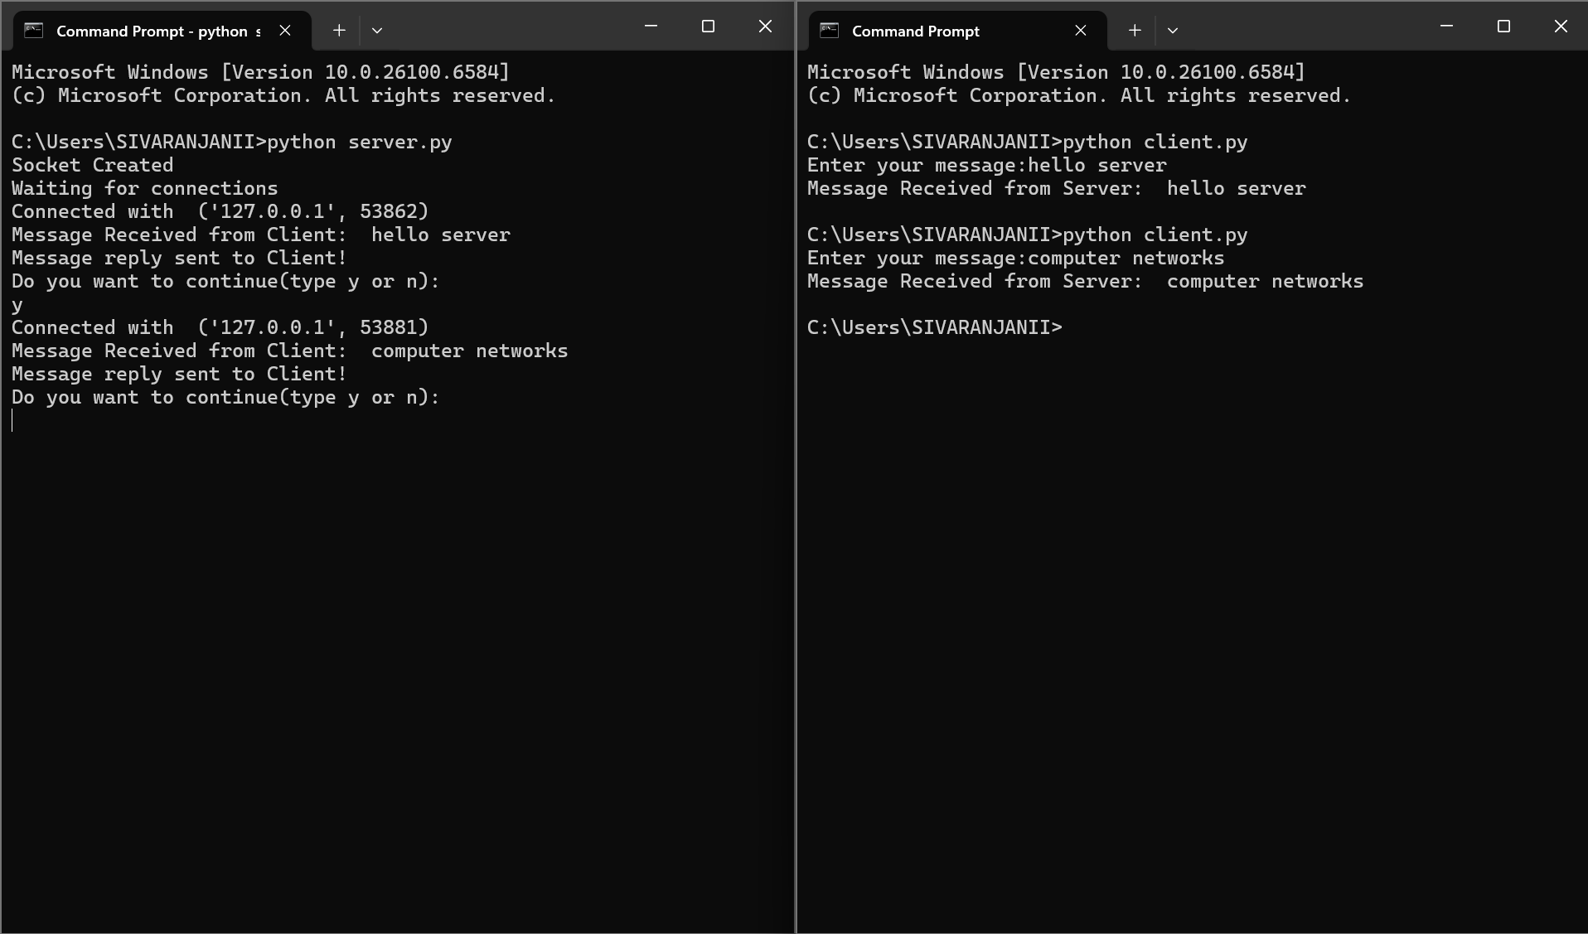

RESULT:
Thus, TCP client-server communication was successfully implemented using Python.

